PROGRAM 6-

P1-

<html>

<head>

<title>program 05</title>

</head>

<body>

<a href="p2.html">

<img src="C:\Documents and Settings\All Users\Documents\My Pictures\Sample

Pictures\Winter.jpg" align="left" width="200" height="200"/>

</a>

</body>

</html>

P2-

<html>

<head>

<title>program 06</title>

</head>

<body> Hi Welcome... </body>

</html>

OUTPUT1-

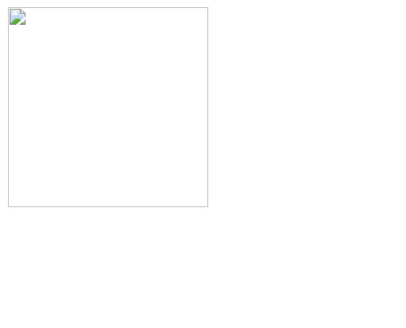

OUTPUT2-

